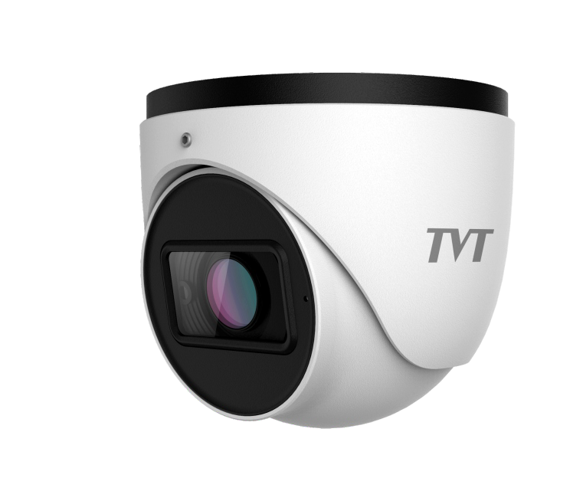 Secure The World With You
8TMDP H-D9Tu5rr8et 5NeStw3orBk Camera
CAMERA

H.265+/H.265/H.264+/H.264/MJPEG coding
Max.resolution: 8MP ( 3840 × 2160 ) ICR auto switch, true day / night vision
3D DNR, true WDR, HLC, BLC, smart IR and ROI coding 30~50m IR night view distance
1CH audio input; 1CH built-in MIC Built-in micro SD card slot, up to 256GB DC12V/PoE power supply
Support three streams IP 67
Support mobile surveillance by smart phones with iOS and Android OS Intelligent analytics

H.265
H.265


Motion Detection
PoE



WDR AWB

PoE IP67



Defog

VCA

HLC

-30°~60°

BLC


en.tvt.net.cn
For more information, please visit our website

Shenzhen TVT DIGITAL TECHNOLOGY CO., LTD.
Address: 23rd Floor, Block B4, Building NO.9, Shenzhen Bay Eco-Technology Park, Nanshan District, Shenzhen, Guangdong Province, P.R.China

Tel: +86-755-36995888 Fax: +86-755-33104777
Web site: http://en.tvt.net.cn E-mail: overseas@tvt.net.cn

SPECIFICATIONS
TD-9585S3B
Camera
8MP Turret Network
Model  Specifications | TD-9585S3B
Camera
Image Sensor | 1 / 2.8 "CMOS
Image Size | 3840×2160
Electronic Shutter | 1 / 2 s ~ 1 / 100000 s
Iris Type | DC Iris
Min. Illumination | 0.02 lux @ F1.6, AGC ON; 0 lux with IR  ~
Lens | 2.8 12mm@F1.6, motorized  ~ |  | ~ | ~
Field of View | Horizontal:99° 33°; Vertical :53° 17°; Diagonal:117° 37°  Φ
Lens Mount | 14
Day&Night | ICR
Wide Dynamic Range | 120dB
BLC | Yes
HLC | Yes
Defog | Yes
Digital NR | 3D DNR
S/N Ratio | ≥50dB
Angle Adjustment | Pan: 0°~360°; Tilt:0°~80°; Rotation: 0°~360°
DORI Distance
Lens | Detect | Observe |  | Recognize | Identify
2.8~12mm(W) | 86.65m(284.28ft) | 34.66m(113.71ft) |  | 17.33m(56.85ft) | 8.66m(28.41ft)
2.8~12mm(T) | 289.06m(552.31ft) | 115.62m(240.12ft) |  | 57.81m(136.06ft) | 28.91m(84.04ft)
Image
Video Compression | Main stream: H.265+ / H.265 / H.264+ / H.264  Sub stream: H.265+ / H.265 / H.264+ / H.264 / MJPEG  Third stream: H.265+ / H.265 / H.264+ / H.264 / MJPEG
H.264 Compression Standard | Baseline Profile/Main Profile/High Profile
Resolution | 8MP ( 3840 × 2160 ), 6MP( 3072 × 2048 ),5MP( 2592 × 1944),  4MP ( 2592 × 1520), 2K(2560 × 1440 ), 3MP(2304 × 1296),  1080P ( 1920 × 1080 ), 720P ( 1280 × 720 ), D1, CIF, 480 × 240
Main Stream | 60Hz : 8MP(1~20fps)/6MP/5MP/4MP/2K/3MP/1080P/720P(1~30fps)  50Hz : 8MP(1~20fps)/6MP/5MP/4MP/2K/3MP/1080P/720P(1~25fps)
Sub Stream | 60Hz: 720P(1~12fps)/D1/480 × 240(1~30fps)  50Hz: 720P/D1/480 × 240(1~25fps)
Third Stream | 60Hz: 720P/D1/CIF/480 × 240 (1~30fps)  50Hz: 720P/D1/CIF/480 × 240 (1~25fps)
Bit Rate | 64 Kbps ~ 12 Mbps
Bit Rate Type | VBR / CBR
Audio Compression | G711A / U
Image Settings | ROI, Saturation, Brightness, Hue, Contrast, Wide Dynamic, image mirror, image flip, Sharpness, NR, etc. adjustable through client software or web browser
ROI | Each ROI to be configured separately
Interfaces
Network | RJ 45 10M/100M self-adaptive Ethernet port
Video Output | No
Audio | 1CH built-in MIC; 1CH audio input
Alarm | No
Storage | Built-in micro SD card slot; up to 256GB
Reset | Yes
Functions
Remote Monitoring | IE browser/ TVT NVR / NVMS / mobile APP
Web Browser | IE11(plug-in required)/Chrome 89.0+/Edge 89.0+/Firefox 87.0+/Safari 14.0+
Online Connection | Support simultaneous monitoring for up to 10 users; Support multi-stream real time transmission
Network Protocol | UDP, IPv4, IPv6, DHCP, NTP, RTSP, RTP, RTMP, RTCP, PPPoE, DDNS, SMTP, FTP, SNMP, HTTP, HTTP POST, 802.1x, UPnP, HTTPs, QoS
Interface Protocol | ONVIF
Storage | Network remote storage; micro SD card storage
Smart Alarm | Motion detection; SD card error; SD card full
Intelligent Analytics | Scene change, video blur detection, abnormal color detection , line crossing detection, intrusion detection

General function | Watermark, video mask, heartbeat,corridor pattern
Security | Video encryption, firmware encryption, HTTPs encryption, configuration encryption, illegal login lock, IP address filtering, 802.1x authentication, basic and digest authentication for HTTP/HTTPs
IR Distance | 30~50m
Protection Grade | IP 67
PoE | Yes (IEEE802.3af)
Others
Power Supply | DC12V/PoE
Power Consumption | < 8W
Storage Conditions | - 30 °C ~ 65°C (-22°F~149°F), Humidity: less than 95 % (non-condensing)
Operating Conditions | - 30 °C ~ 60 °C (-22°F~140°F), Humidity: less than 95 % (non-condensing)  Φ
Dimensions ( mm ) | 111.5 × 99.6
Weight ( net ) | Approx. 0.661KG
Installation | Ceiling mounting; Wall mounting
Certificate | CE, FCC
Environmental Protection | Complies with Directive EU RoHS, WEEE(2012/19/EU) , directive 94/62/EC and REACH(EC1907/2006)

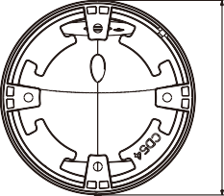
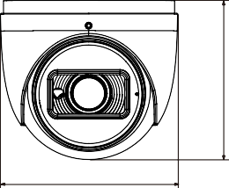 DIMENSIONS
111.50mm
99.60mm
111.50mm

AVAILABLE ACCESSORIES

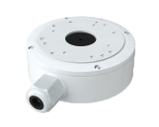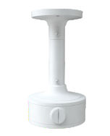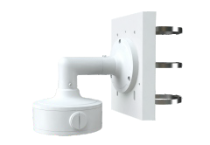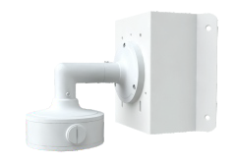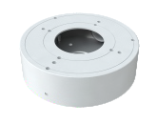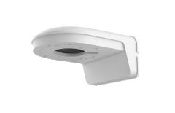
TD-YXH0302+ TD-YZJ0811
TD-YXH0302+
TD-YZJ0407+TD-YZJ0601
TD-YXH0302+
TD-YZJ0407+TD-YZJ0501
TD-YZJ0203
TD-YXH0106
TD-YXH0302

AVAILABLE MODEL

en.tvt.net.cn
*All pictures and specifications are for reference only and are subject to change without prior notice.

TD-9585S3B(D/AZ/PE/AR3)
Available Model

